
Company
Logotype

Cone Beam Computed Tomography- Report



Porur Dental X-rays & CBCT

Patient Name : Mrs. Mahalakshmi | Date of Report : 19.05.2024
Age/ Gender : 38 years/ Female | Region of Interest : CBCT Full Skull
Referring doctor: Dr. Leo | Indication : Implant assessment
Clinical Notes: Nil
PATIENT INFORMATION

CBCT- Full Skull provided
CBCT – IMAGE DETAILS

RADIOGRAPHIC INTERPRETATION

- Complete loss of crown and root structure in relation to 26, 28, 36, 38, 48.
- Root stumps in relation to 13, 14, 15, 16, 17, 18, 23, 24, 25, 27, 33, 34, 35, 37, 43, 44, 45, 47.
- Hyperdense crown structures in relation to 11, 12, 21, 22, 31. 32, 41, 42, 46.
- The alveolar ridge in relation to the maxillary and mandibular alveolar ridge is present with normal trabecular pattern.
- Deviated nasal septum towards the right side.

IMPLANT ASSESSMENT

 | 11 region | 12 region | 13 region | 14 region | 21 region | 22 region | 23 region | 24 region
Sub-Crestal | 6.4 | 4.5 | 7.9 | 9 | 5.4 | 7.3 | 6.4 | 7.9
Mid- Crestal | 7.6 | 3 | 7 | 8.4 | 5.7 | 7.9 | 6.9 | 7.7
Distance between the alveolar ridge and Floor of the Nasal cavity (in mm) | 22.2 | 18.3 | 16.4 | 17.7 | 18.6 | 23.4 | 17.5 | 17.5

 | 15 region | 16 region | 17 region | 25 region | 26 region | 27 region
Sub-Crestal (in mm) | 10.6 | 10.9 | 8 | 8.7 | 8 | 10.7
Mid- Crestal (in mm) | 11.7 | - | - | 8.7 | 11.8 | -
Distance between the alveolar ridge and floor of the maxillary sinus (in mm) | 10.3 | 3.1 | 3.6 | 13.4 | 6 | 4

 | 31 region | 32 region | 33 region | 34 region
Sub-Crestal (in mm) | 4.4 | 4.7 | 6.4 | 7.4
Mid- Crestal (in mm) | 5.1 | 5 | 5.7 | 7.3
Distance between alveolar ridge and the inferior border of mandible (in mm) | 21.4 | 24.1 | 29 | 23.5

 | 41 region | 42 region | 43 region | 44 region
Sub-Crestal (in mm) | 5.6 | 6.4 | 5.5 | 7.4
Mid- Crestal (in mm) | 5.7 | 4.3 | 5.8 | 6.8
Distance between alveolar ridge and the inferior border of mandible (in mm) | 24.6 | 27.4 | 21.9 | 24.1
 | 45 region | 46 region | 47 region
Sub-Crestal (in mm) | 6.9 | 10.3 | 9.2
Mid- Crestal (in mm) | 8.1 | 10.9 | 11.5
Distance between alveolar ridge and the inferior alveolar nerve canal (in mm) | 18.3 | 15.8 | 11.6
Distance between alveolar ridge and the inferior border of mandible (in mm) | 27.5 | 24.8 | 20.8

 | 35 region | 36 region | 37 region
Sub-Crestal (in mm) | 7 | 6.7 | 9.5
Mid- Crestal (in mm) | 7.6 | 7.1 | 10.5
Distance between alveolar ridge and the inferior alveolar nerve canal (in mm) | 17 | 16.1 | 8.5
Distance between alveolar ridge and the inferior border of mandible (in mm) | 26.8 | 27.3 | 19.9

RADIOGRAPHIC IMPRESSION

- Partially edentulous maxillary and mandibular arch.
- Root stumps in relation to 13, 14, 15, 16, 17, 18, 23, 24, 25, 27, 33, 34, 35, 37, 43, 44, 45, 47.
- Crown in relation to 11, 12, 21, 22, 31. 32, 41, 42, 46.

Kindly correlate with clinical findings


IMAGES FOR REFERENCE

RECONSTRUCTED PANORAMIC VIEW
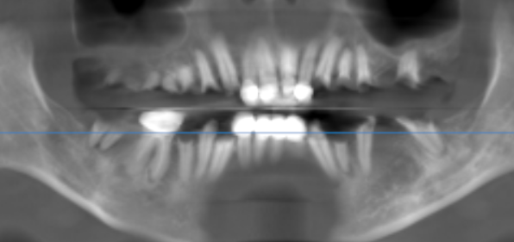

3-DIMENSIONAL VIEW
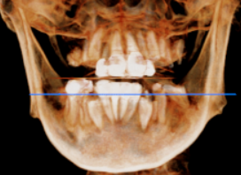

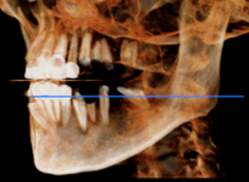
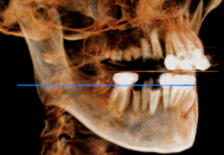

CROSS SECTIONAL VIEW

11 region | 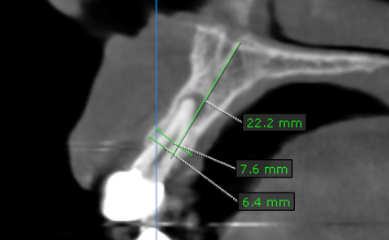
12 region | 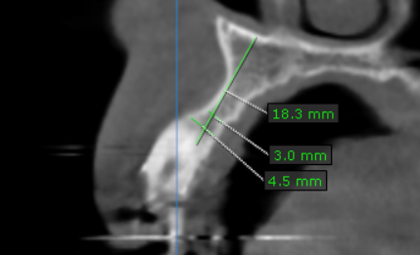
13 region | 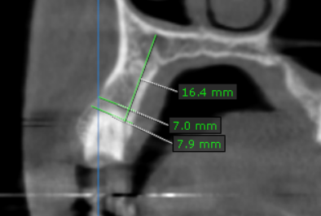
14 region | 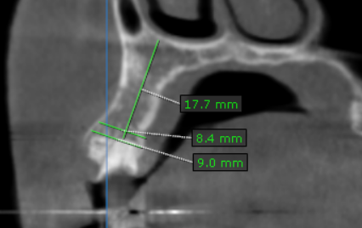
15 region | 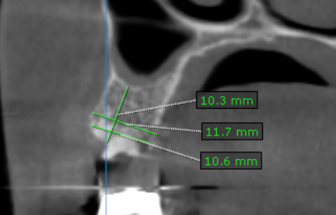
16 region | 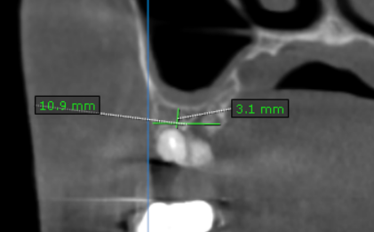
17 region | 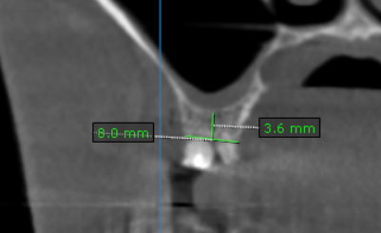
21 region | 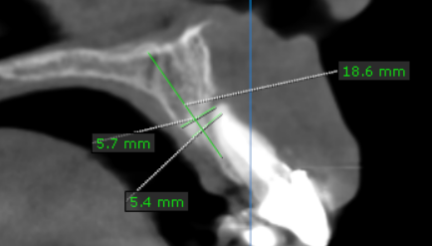
22 region | 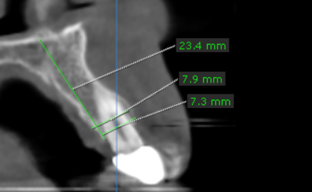
23 region | 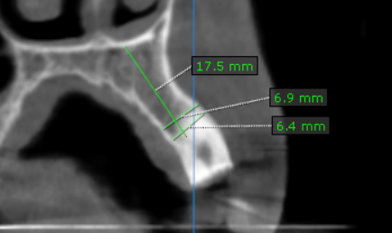
24 region | 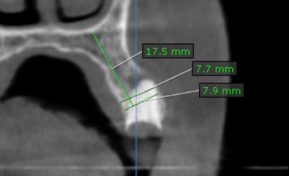
25 region | 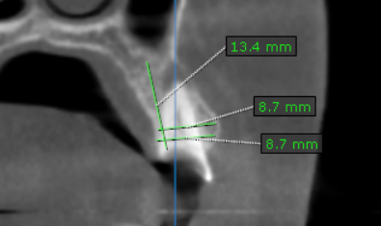
26 region | 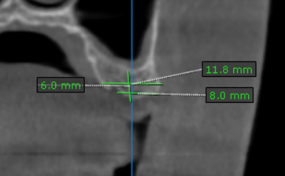
27 region | 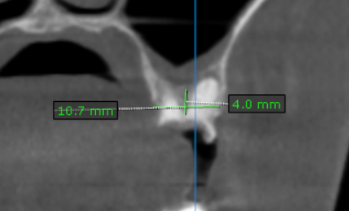
31 region | 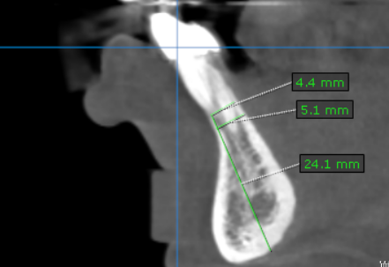
32 region | 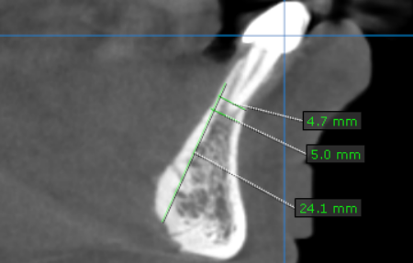
33 region | 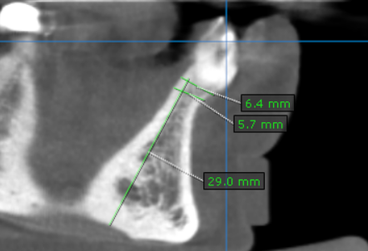
34 region | 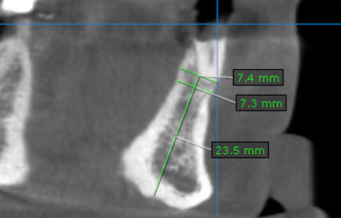
35 region | 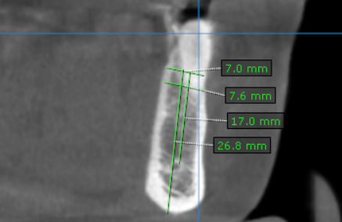
36 region | 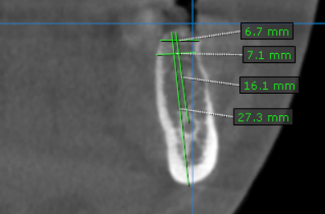
37 region | 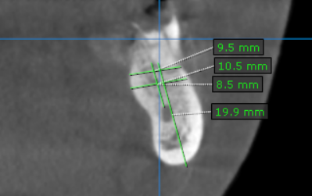
41 region | 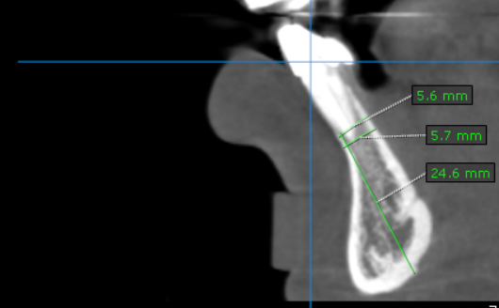
42 region | 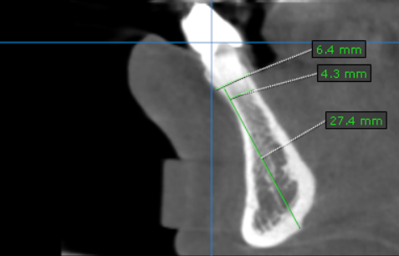
43 region | 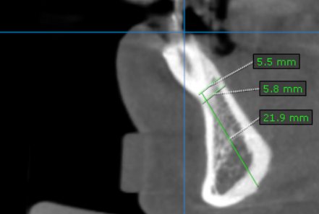
44 region | 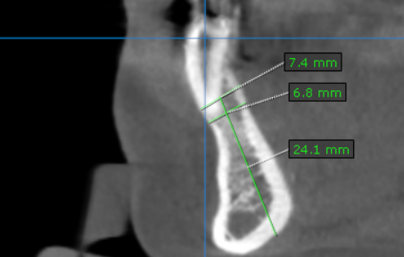
45 region | 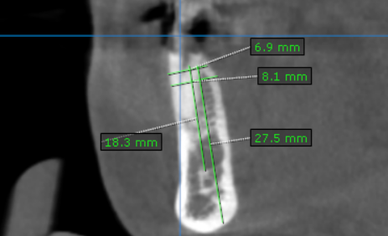
46 region | 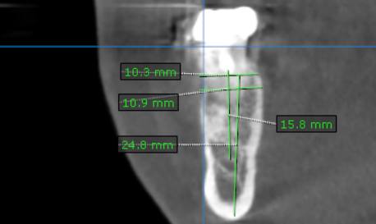
47 region | 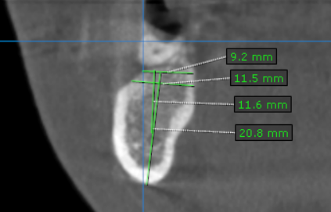

**** End of report ****

